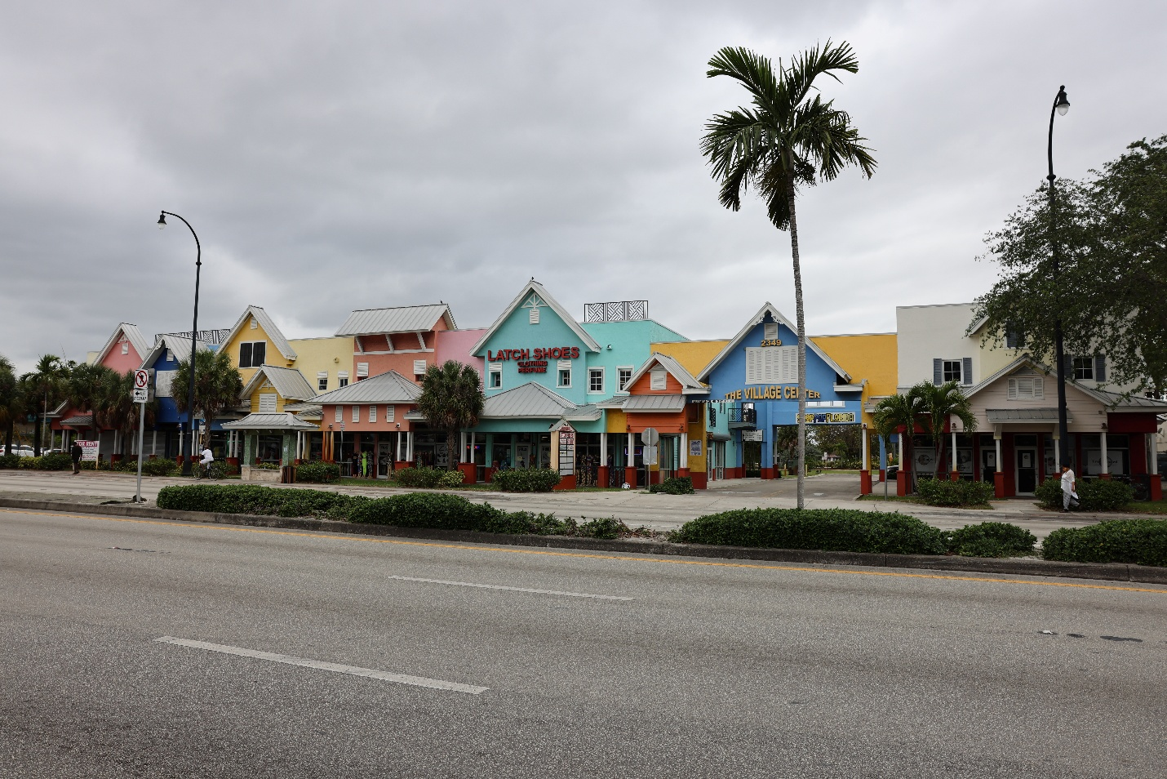

The Village Center Harnarrine Development
Owner: Latch Harnarrine
2300 – 2400 SR-7 (US 442)
Lauderhill Florida, 33313

Architect: ADG – D2F

Type: Commercial - Retail
Location: Lauderhill Florida
Contractor: Quantities Inc
Cost: $3,200,000
